When designing a website, it is very important to keep in mind the recommended web practices that we went over in Module 2. For this assignment, you will plan a website about your favorite hobby, subject, your family, a church or club you belong to, a company a friend owns, or a company you work for, or a portfolio website.

As you plan, aim for a website that should have at least 3 pages, but no more than ten content pages.

Answer the following questions with as much details as possible!

1. What will be the topic of your website?
2. In a paragraph describe **the purpose** of your website.
3. What **goal** do you want your website to accomplish? List at least 2 goals you have for the website. Remember goals must be **measurable**.
4. Who is your target audience? Describe the audience by age, gender, socioeconomic characteristic and so on. (You may refer to this guide: <https://www.quicksprout.com/define-your-target-audience/>)
5. What topics will your website contain? In other words, what are the pages that you want to have for your website? (You should think of 3 to 10 pages)
6. Draw your site map for your idea (utilizing word, or even by hand), for example:

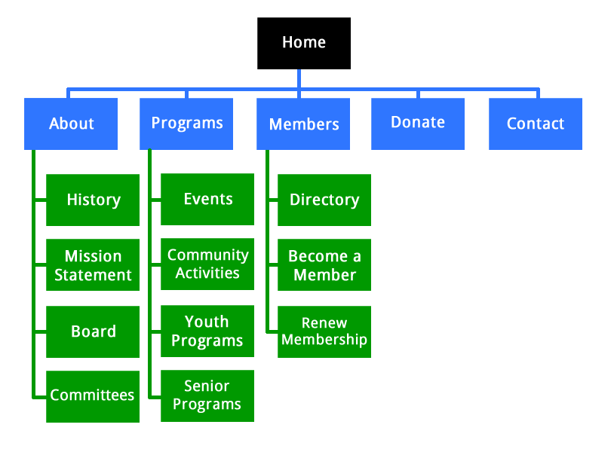

1. What type of content will your website include (text, video, audio)? What types of text, graphics, and media will the website have?
2. Draw a wireframe for the homepage of your website. (The wireframe can be create on paper, or through Word, Paint, Photoshop or any type of software that allows you to sketch. This wireframe does not need to be detailed, it is okay to just have a sketch of what your want your page to look like).
3. If you could have any DOMAIN name in the world, what domain would you use for your website?
4. Research other websites on the web. Provide the URL to 2 websites that are similar to the website you want to create.
5. What color scheme might you use? Pick some colors that might go well with your website theme and idea. Below are some resources to help you find this answer:
   * You can come up with your own color scheme with colors that represent your ideas and preferences. However, keep in mind the contrast. You can check for contrast here: <https://webaim.org/resources/contrastchecker/>
   * You can get ideas from using the color wheel from adobe or any other website, for example: <https://color.adobe.com/create/color-wheel>
6. What color will be the dominant color of your website? (Provide the HEX code: )
7. What colors might you use for text (foreground)? (Provide the HEX code: )
8. What colors might you use for background? (Provide the HEX code: )
9. Are there any other colors you might use? (Provide the HEX code for each)
10. What type of color scheme are your using (Monochromatic, complimentary, analogous, or other?)
11. Use the contrast checker, to compare your text color and background color (links provided above). Do they meet the WCAG AA standard? If not, change the lightness or darkness of colors until they meet it. Change the answer above with values that meet the accessibility standard.
12. Create a case scenario (or persona). Invent a person who might go use your website that fits the target audience. Give this person a name, age, gender, job description, educational background, what type of hobbies does this person have? Why is this person accessing your website (what is their motivation)? What will this person do once they reach your website? Where are they accessing your website from? What types of considerations should you make to ensure this persona enjoys their experience in your website?